Proposal Phase Report
Team ID: 4A10
Category: Application Development

Title: Primary Health Care Center Patient Database

List of Team Members: Apoorva Surendra Malemath

Team Leader: Apoorva Surendra Malemath

Responsibilities: [express the initial responsibilities of each team member for the proposal phase]
What is the role of each project member in this phase of project? (Be specific)
- Communicating with the client.
- Interpreting the problem statement.
- Brainstorming the possible solutions for the problem statement.
- Implementing the ER model.
- Deriving the relational schema.
- Attaining Data Dictionary.

Problem Description: [give a detailed description of what is the real time problem that you came across which motivated you in proposing this as your course project]
The task of saving the lives and ensuring good health of the citizens throughout the state lies in the hand of the government. The most important asset of a country is the good health of its citizens. Thus, primary health care center is made accessible to all the individuals and the family in the community.
But the primary health care centers do not have any formal records of detailed patient records. Monitoring of patient record is mandatory as the government can properly plan about how to minimize the casualties of any disease.
Recording all the details of an individual is crucial as it helps the doctors to understand the patient’s health conditions perfectly and act accordingly. It is a common scenario that usually the patient is unaware of the intricate details of his chronic illness, wherein if there is no previously stored data, then there are chances that the doctor might not get the complete detail of the patient’s medical status leading to inefficient prescription of medicines.
Also depending on the cases registered, it will be easy for the government to properly plan how to reach out to the public in the most efficient way.

Requirements: [list out the issues that you will be addressing]
What are the application functional specifications (i.e., what functionality will your completed system provide)? You will have to account for each one of the functionality in your demo.

The Primary health care center patient database system is a database management system that uses database technology to construct, maintain and manipulate various kinds of data about a person’s medical history and care across time. The DBMS can track and update all the information of registered patients in the primary care center.
Medical records are created when a patient receive treatment from a government health professional. Records include the patients:
- Personal information
- Medical history
- Laboratory test results
- Medications prescribed
- Reports that indicate the results of operations and other medical procedures
- Disabilities
- Allergies
- Insurance
- Eligibility for government programs.
- Analysis of trends in common diseases.
The medical record serves a variety of purposes and is essential to the proper functioning of the medical practice. Especially in today’s complicated health care environment. The medical record is a key instrument used in planning, evaluating, and coordinating patient care.

Design Questions to be answered
[Note: Complete a logical design of a database. This section of the course project involves designing a database schema based on problem specification stated. Here, you need to submit a report summarizing your design which includes Entity-Relationship Model, ER to Relational mapping, data dictionary. (You need to design using any of the designing tools that you have access to such as UML, ER Modeling, etc.)]
Entity | Attributes
Patient | Aadhar_no, First_Name, Middle_Name, Last_Name, DOB, Age, Pin_code, Contact_no, Economic_status, Photo
Emergency_Contact | Name, Relationship, Contact_no, Address
Allergy | Substance_name
Disability | Disability_name
Insurance | Insurance_no, Name, Address, Contact_no, Category
Operation | Op_no, Name, Date, Details, File
Diagnosis | Visit_id, Date, Description
Disease | Disease_ID, Category
Prescription | Prec_id, Med_name, Quantity, Price, Bill_Amt
Test_Reports | Rep_ID, Rep_name, file
Scheme | Scheme_ID, Name
Question 1: From the problem description, identify the entities that need to be represented in the database, the attributes of each entity, the relationships between the entities, and the cardinality ratios of each relationship.

Entity Name | Entity Type | Relationship | Entity Name | Entity Type | Cardinality ratio
Patient | Strong Entity | Has | Emergency_contact | Weak Entity | 1:N
Patient | Strong Entity | Owns | Insurance | Strong Entity | 1:1
Patient | Strong Entity | Undergone | Operation | Weak Entity | 1:N
Patient | Strong Entity | Is Allergic | Allergy | Weak Entity | 1:N
Patient | Strong Entity | Has | Disability | Weak Entity | 1:N
Patient | Strong Entity | Undergoes | Diagnosis | Strong Entity | N:M
Patient | Strong Entity | Owns | Test_reports | Weak Entity | 1:N
Patient | Strong Entity | Is Eligible | Scheme | Strong Entity | M:N
Diagnosis | Strong Entity | Yields | Prescription | Strong Entity | 1:1
Diagnosis | Strong Entity | Determines | Disease | Strong Entity | 1:1

Question 2: Draw an Entity-Relationship Diagram illustrating the information you have identified in Question 1.
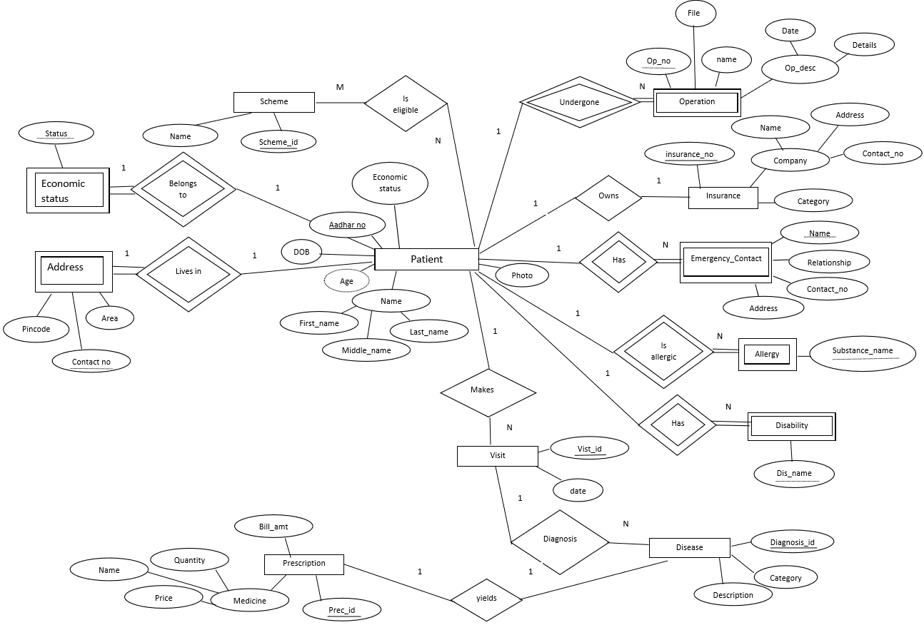
ER diagram 1
Question 3: Draw alternate Entity-Relationship Diagram illustrating the information you have identified in Question 1 that you think are most likely to occur.
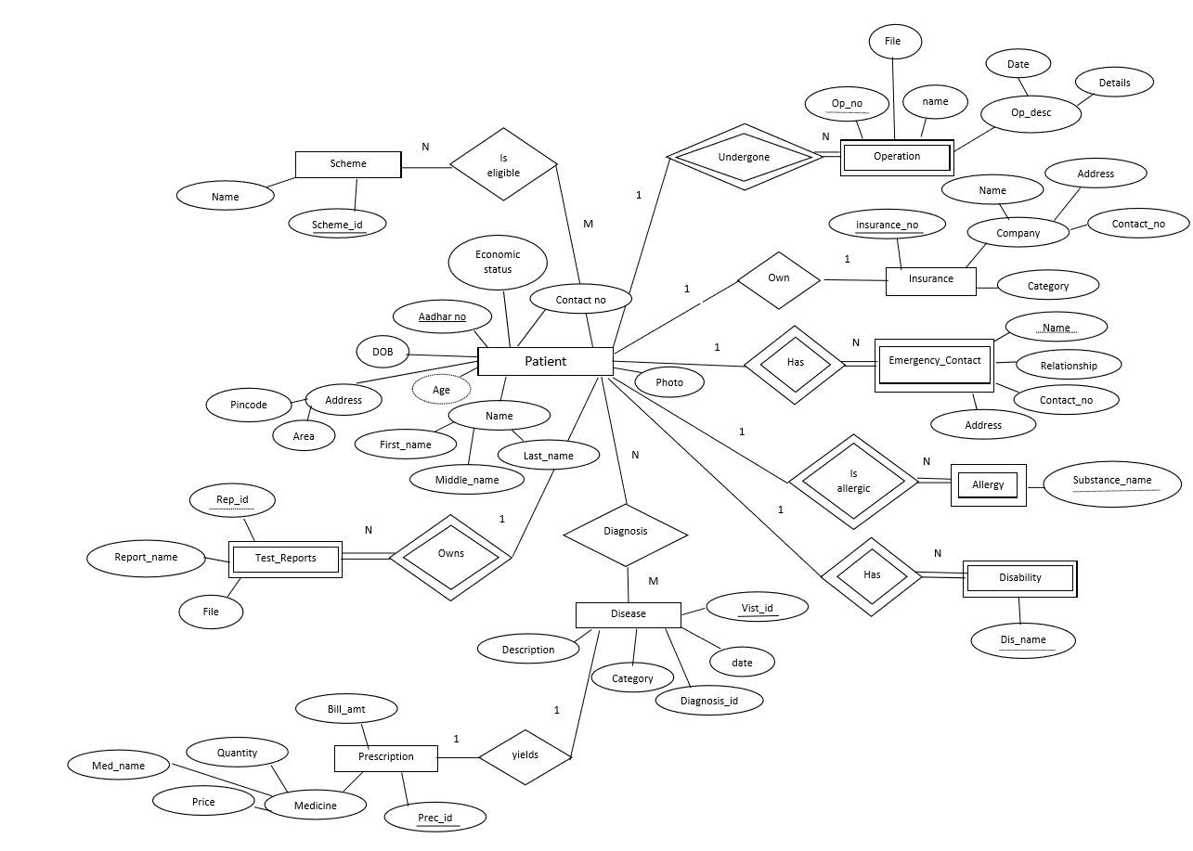
ER diagram 2

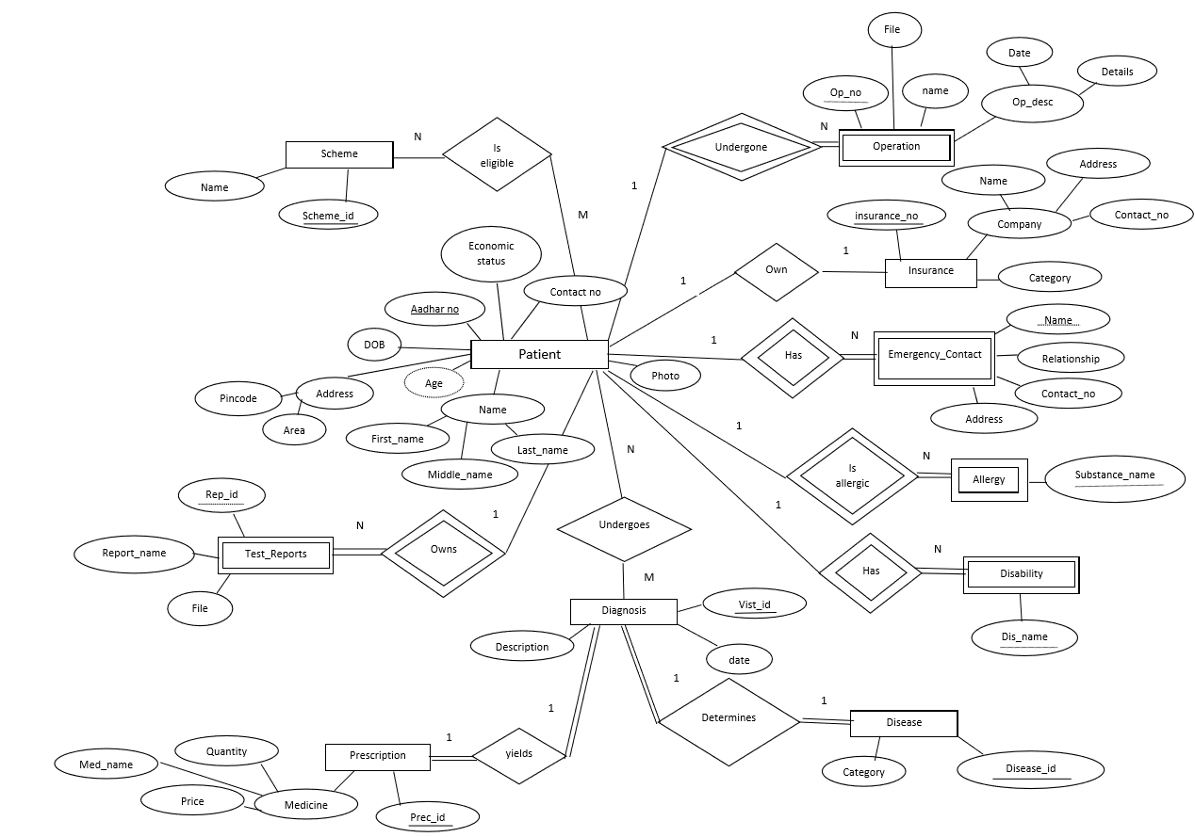
ER diagram 3
Repeat Question 3 if you have many alternate ER designs.
Question 4: Choose the optimal Entity-Relationship Diagram from the designs provided above and justify why you think this is an optimal solution for your identified problem specification.
ER diagram 3 provides an optimal solution because:
- Designing is an iterative process and the shortcomings in the ER diagram 1 haven been given focus to and rectified.
Two weak entities namely Economic_status and Address in ER diagram 1 have been removed and have been put under Patient entity in ER diagram 3 as this prevents unnecessary existence of two extra tables with the attributes which can be used under patient entity, thus customizes it.
- It provides new entity named Test_Reports.
On further brain storming over ER diagram 1 and communicating with the client, new perspective towards the problem statement has been included. i.e. The system must provide an option to store files such as x-rays, test reports, etc.
- It is an improvement over the previously made model as it increased the understanding of data flow and relationship.
There is ineffecient use of diagnosis_id under the entity named diagnosis in ER diagram 2, which has been replaced and optimized by making use of two entities namely diagnosis and disease in ER diagram 3, thus establishes better relationship among the entities.
- The attributed named bill_amt in prescription entity of ER diagram 1 has been removed as it is inappropriate to use it. Because it will be present for each tupple. Instead the bill amount can be exernally calculated through on simple calculations.
- It provides an additional attribute to store the image of the patient on client’s demand.
Thus, The ER diagram 3 is optimized and has a better approach towards solving the problem, and provides better relationships among entities.

[Optional] Question 5: Draw an Object Model illustrating the information you have identified in Question 2.
DRAW YOUR OBJECT MODEL DIAGRAM HERE

Question 6: Draw an ER to Relation Mapping illustrating the information you have identified in Question
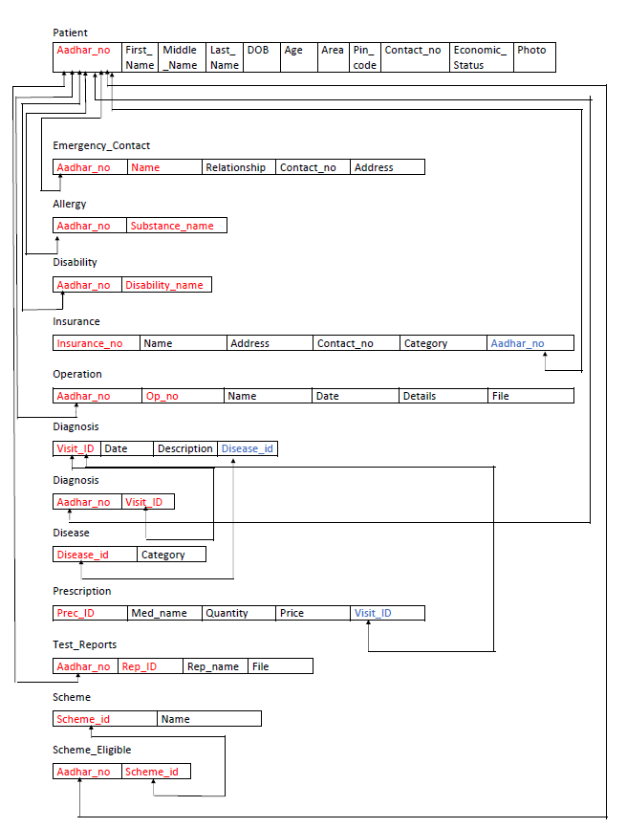

Question 7: Draw a Data Dictionary illustrating the information you have identified in Question 6.
DRAW YOUR DATA DICTONARY DIAGRAM HERE
Format for data dictionary is as follows:
Object (Entity) | Name (Attribute) | Type  (Data type) | Description | Primary Key | Foreign Key
Patient | Aadhar_no | String | Unique Identification number for the patient. | Yes | No
Patient | Frist  _Name | Integer | First name of the patient. | No | No
Patient | Middle_Name | String | Middle name of the patient. | No | No
Patient | Last_Name | String | Last name of the patient. | No | No
Patient | DOB | Date | Date of birth of the patient. | No | No
Patient | Age | Integer | Current age of the patient. | No | No
Patient | Area | String | Residential address of the patient. | No | No
Patient | Pin_code | String | Pin code of the area that the patient resides. | No | No
Patient | Contact_no | String | Contact number of the patient. | No | No
Patient | Economic_Status | String | Economic status of the patient i.e APL or BPL. | No | No
Patient | Photo | File attachment | Image of the patient. | No | No
Emergency_Contact | Aadhar_no | String | Unique Identification number for the patients. | No | Yes
Emergency_Contact | Name | String | The name of the emergency contact (Family/Guardian). | No | No
Emergency_Contact | Aadhar_no, Name | String, String | Together they act as a primary key. | Yes | No
Emergency_Contact | Relationship | String | Relationship of the patient with the given emergency contact. | No | No
Emergency_Contact | Contact_no | String | Contact number of the emergency contact. | No | No
Emergency_Contact | Address | String | Residential address of the emergency contact. | No | No
Allergy | Aadhar_no | String | Unique Identification number for the patient. | No | Yes
Allergy | Substance_name | String | Stores the name of the substance that the patient is allergic to. | No | No
Allergy | Aadhar_no, Substance_name | String, String | Together they act as a primary key. | Yes | No
Disability | Aadhar_no | String | Unique Identification number for the patient. | No | Yes
Disability | Disability_name | String | Records disability, if exists. | No | No
Disability | Asdhar_no, Disability_name | String, String | Together they act as a primary key. | Yes | No
Insurance | Insurance_no | String | The insurance number. | Yes | No
Insurance | Name | String | The name of the insurance company. | No | No
Insurance | Address | String | Address of the insurance company. | No | No
Insurance | Contact_no | String | Contact number of the insurance company. | No | No
Insurance | Category | String | Type of the insurance i.e. the category | No | No
Insurance | Aadhar_no | String | Unique Identification number for the patient | No | Yes
Operation | Aadhar_no | String | Unique Identification number for the patient. | No | Yes
Operation | Op_no | String | Unique identification number for each operation performed on the patient. | No | No
Operation | Aadhar_no, Op_no | String, String | Together they act as a primary key. | Yes | No
Operation | Name | String | Name of the operation performed on the patient. | No | No
Operation | Date | Date | Operation date | No | No
Operation | Details | String | Details related to the operation. | No | No
Operation | File | File attachment | Files including reports and operation details. | No | No
Diagnosis | Visit_id | String | Unique Identification for each visit that any patient makes. | Yes | No
Diagnosis | Date | Date | Date of the visit. | No | No
Diagnosis | Description | String | Brief description of the disease | No | No
Diagnosis | Disease_id | String | Unique Identification number for the disease diagnosed`. | No | Yes
Disease | Disease_id | String | Unique Identification number for the disease diagnosed`. | Yes | No
Disease | Category | String | The predefined category that the disease belongs to. | No | No
Prescription | Prec_id | String | Unique Identification number for each prescription. | Yes | No
Prescription | Med_name | String | Name of the medicine that has been prescribed. | No | No
Prescription | Quantity | Integer | Quantity of medicine prescribed. | No | No
Prescription | Price | Float | Price of each medicine prescribed. | No | No
Prescription | Bill_Amt | Float | Total bill amount of the prescription. | No | No
Prescription | Visit_ID | String | Unique Identification for each visit that any patient makes. | No | Yes
Test_Reports | Aadhar_no | String | Unique Identification number for the patient. | No | Yes
Test_Reports | Rep_ID | String | Unique Identification number of each report that belongs to a patient. | No | No
Test_Reports | Aadhar_no, Rep_ID | String, String | Together they act as a primary key. | Yes | No
Test_Reports | Rep_name | String | Name of the report. | No | No
Test_Reports | File | File attachment | Files such as x-rays, reports stored as attachment. | No | No
Scheme | Scheme_id | String | Unique Identification number of each scheme available from the government. | Yes | No
Scheme | Name | String | The name of the scheme. | No | No
Scheme_Eligible | Aadhar_no | String | Unique Identification number for the patient. | No | Yes
Scheme_Eligible | Scheme_id | String | Unique Identification number of each scheme available from the government. | No | No
Scheme_Eligible | Aadhar_no, Scheme_id | String, String | Together they act as a primary key. | Yes | No

References:
Cite all the reference documents, books, websites, design tools, etc adopted in your work.
[Note: Use design tools for drawing all diagrams expected above]
http://www.karnataka.gov.in/hfwsecretariat/Pages/Primary-Health-Centres.aspx
https://docs.oracle.com/cd/E11882_01/gateways.112/e12072/c_examples.htm#IMSUG242
http://apolloahd.com/patient_registration_form.php
https://creately.com/diagram/example/i1q1hvlv2/Patient%20Registration%20System
https://www.academia.edu/5702596/ROLE_OF_PRIMARY_HEALTH_CARE_CENTRES_IN_KARNATAKA

Submission Date: 16/02/2018

